SMART TRAFIC SIGNALLING

TRAFFIC DATA INPUT:
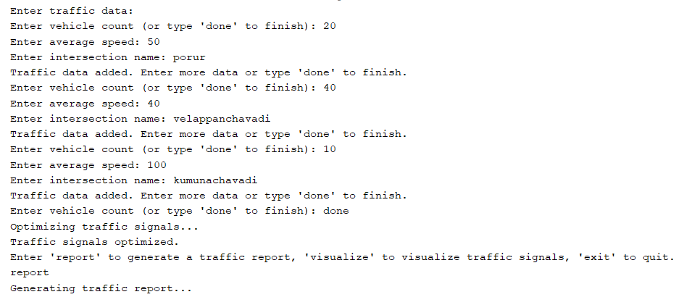

TRAFFIC REPORT 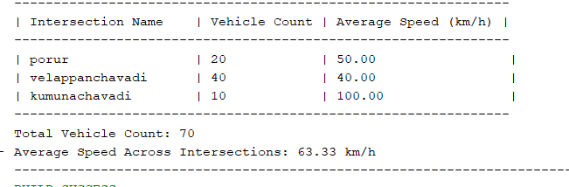

TRAFFIC SIGNAL
